Supplementary
Not within spitting distance: salivary immunoassays of estradiol have subpar validity for cycle phase
Ruben C. Arslan^{1,2}, Khandis Blake³, Laura J. Botzet⁴, Paul-Christian Bürkner⁵, Lisa DeBruine⁶, Tom Fiers⁷, Nick Grebe⁸, Amanda Hahn⁹, Ben C. Jones¹⁰, Urszula M. Marcinkowska¹¹, Sunni L. Mumford¹², Lars Penke⁴, James R. Roney¹³, Enrique F. Schisterman¹², Julia Stern¹⁴

Reproducible code documentation: https://rubenarslan.github.io/invalidity_on_steroids/

Supplementary Note 1: Literature search on assays 2
Supplementary Figure 1 3
Supplementary Figure 2 4
Supplementary Figure 3 5
Supplementary Note 2: Estradiol peaks as cycle phase measure 6
Supplementary Figure 4 7
Supplementary Note 3: Calculating the expected correlation between serum and saliva 8
Supplementary Note 4: Anovulation rates and imputation accuracy by age 10
Supplementary Figure 5 10
Supplementary Figure 6 11
Supplementary Note 5: Serum steroids according to the serum luteinizing hormone surge 12
Supplementary Figure 7 12
Supplementary Note 6: Urinary validity data. 13
Supplementary Note 7: Methodological details for each study. 14
Supplementary Note 8: All model sample sizes. 17
Supplementary References 19

Supplementary Note 1: Literature search on assays
We performed the following search on SCOPUS.
Journal: Psychoneuroendocrinology or Hormones and Behavior
In abstract, title or keywords: Menstrual Cycle, Estradiol
Limited to articles published 2017 or later.

RCA then examined the full text of each article to code the following information:
- Is the article an empirical primary study related to menstrual cycle effects?
- Did researchers collect saliva, serum, urine, or something else?
- How was estradiol assayed?

The search terms yielded N=58 papers. Of those, n=42 papers were empirical primary studies with at least one research question related to menstrual cycle changes within-individuals. Of those, n=1 used an app-based symptom tracking approach, n=1 collected urine, n=2 collected serum, and n=37 collected saliva and assayed estradiol. The estradiol immunoassays studied here, i.e. Salimetrics, IBL, and DRG immunoassays accounted for 78% of the assays performed on salivary estradiol (ns=12, 11, 6). In most cases, the progesterone assay was done using kits from the same company. Of studies using salivary estradiol assays, n=22 were published in Psychoneuroendocrinology, n=15 in Hormones and Behavior.

Supplementary Figure 1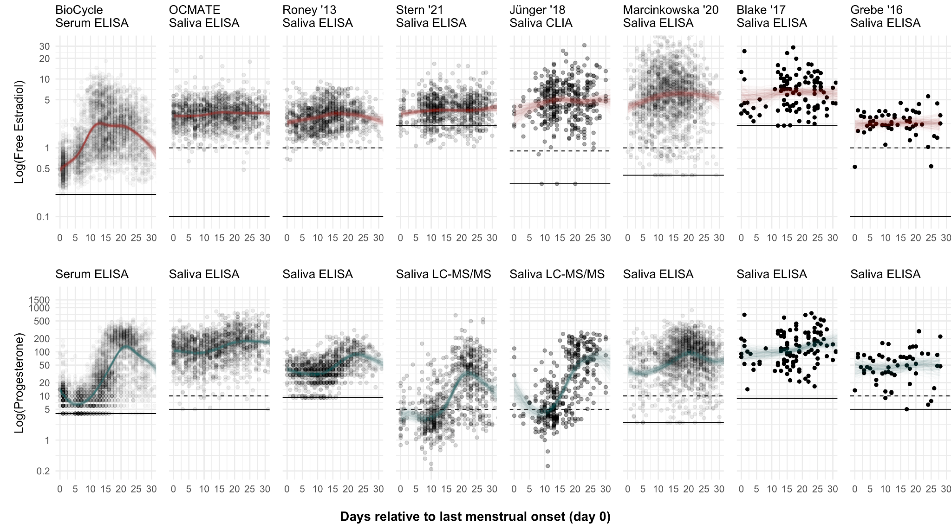
Supplementary Figure 1. Associations with cycle day relative to the recalled or observed last menstrual onset in all datasets. Dots show raw data. Coloured lines show two hundred random samples of the thin-plate spline fit using a Bayesian multilevel regression. Solid horizontal lines show the limit of detection; dashed the limit of quantitation. Progesterone values for BioCycle were multiplied by 2% as per Wood (2009) to make scales comparable.

Supplementary Figure 2
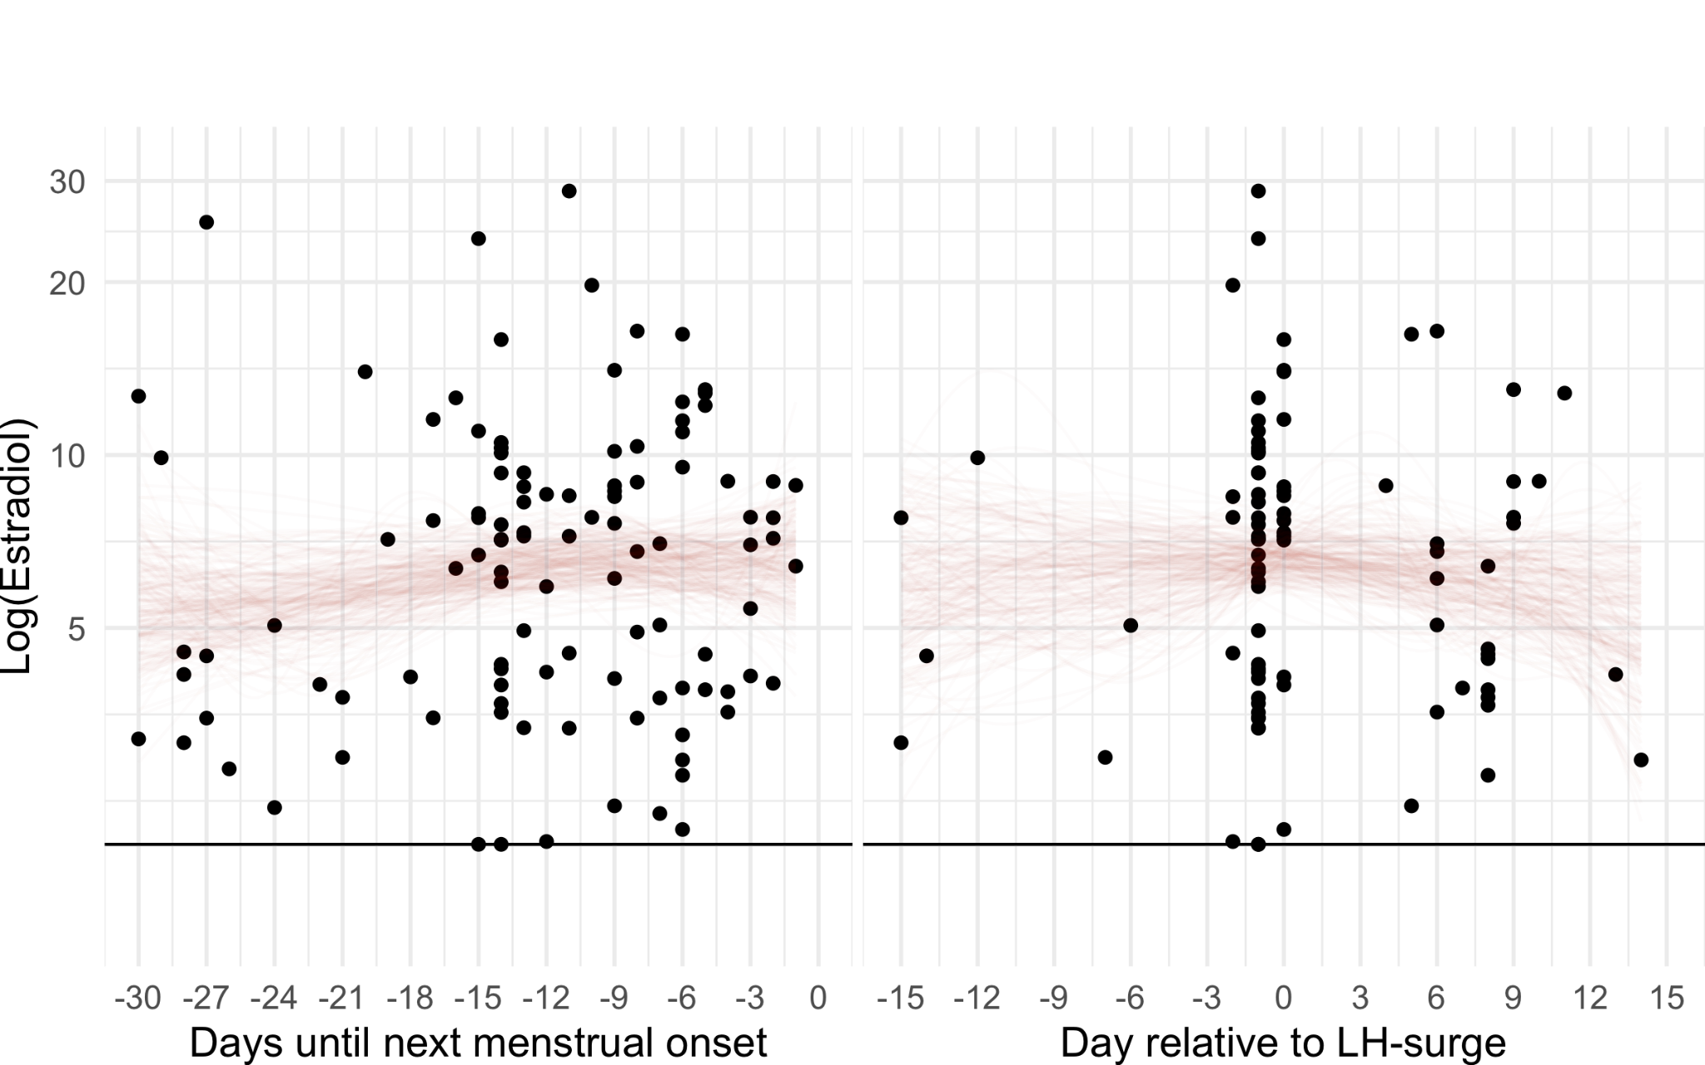
Supplementary Figure 2. Associations with cycle day relative to the observed next menstrual onset and relative to the LH surge in Blake et al. (2017). Dots show raw data. Coloured lines show two hundred random samples of the thin-plate spline fit using a Bayesian multilevel regression. Solid horizontal lines show the limit of detection.

Supplementary Figure 3
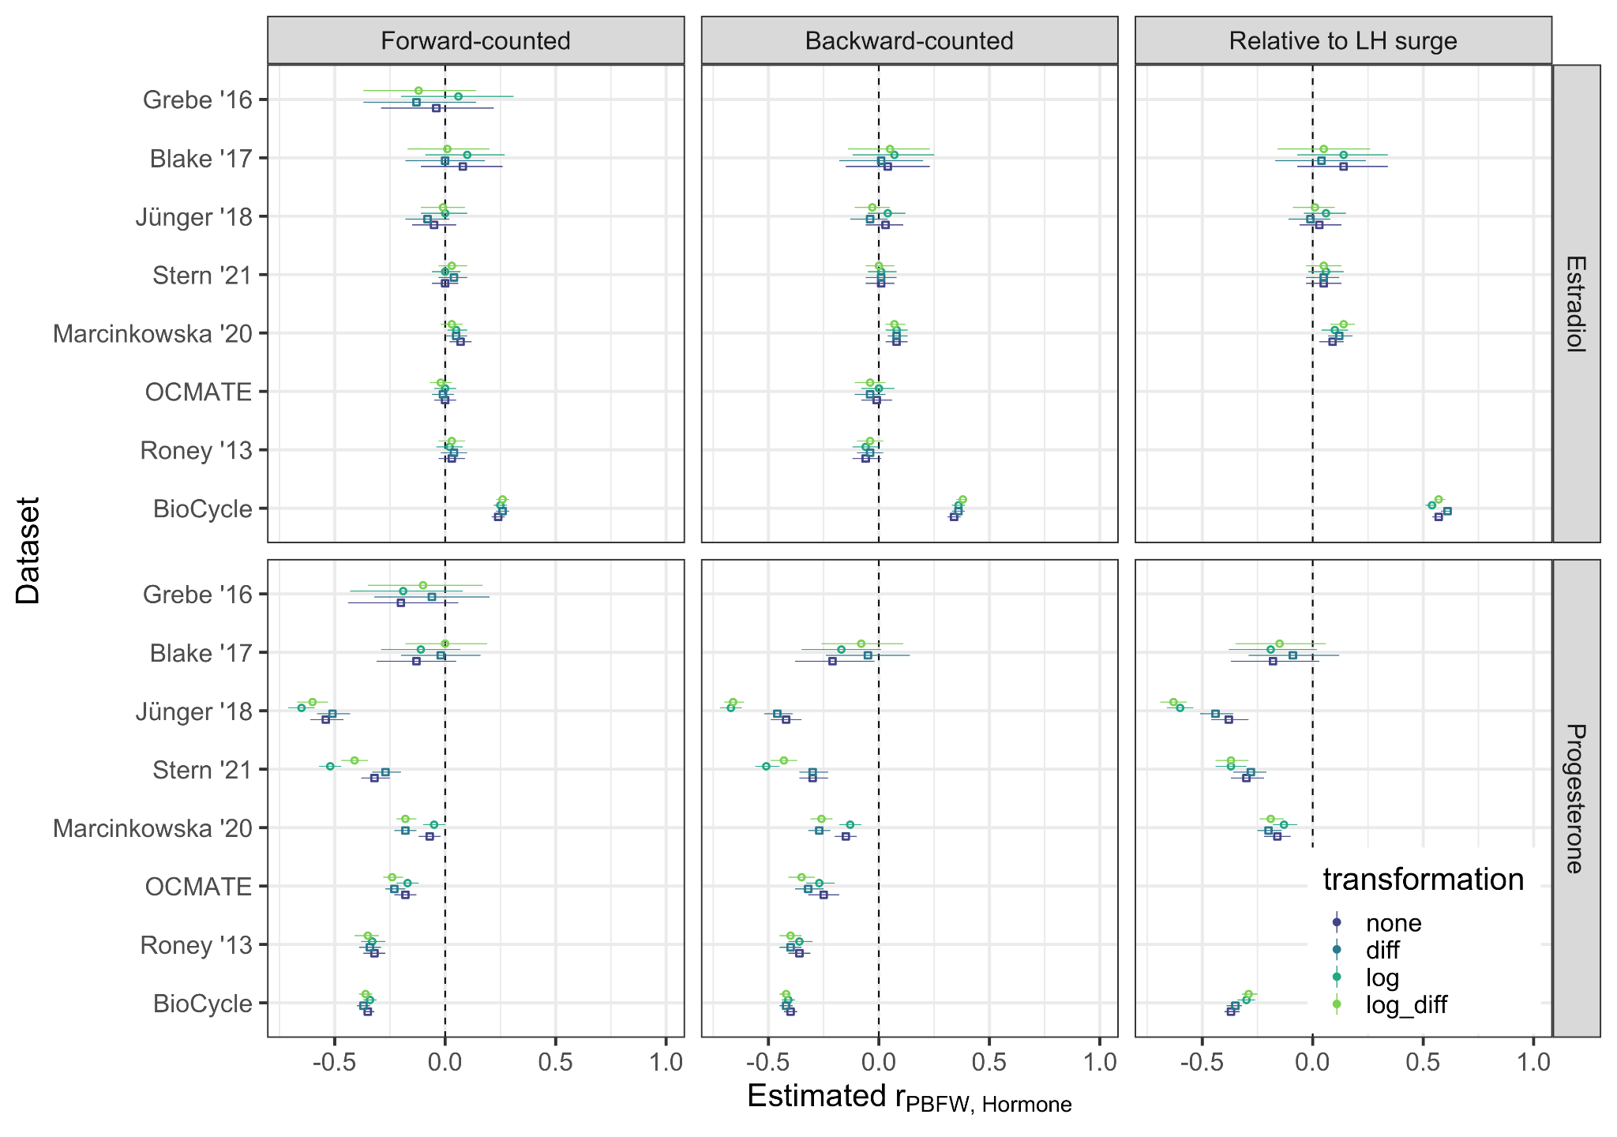
Supplementary Figure 3. Correlations between probability of being in the fertile window, according to forward-counting, backward-counting, and the LH surge, and hormone measures in various transformations (none, within-subject differences, log, within-subject differences from log).

Supplementary Note 2: Estradiol peaks as cycle phase measure
Several studies have employed salivary steroids themselves to estimate the day of ovulation. Algorithms vary and are sometimes not well-described, but one common approach is to identify the day of the highest E2 peak. If our steroid-independent measures are more noisy than we think, a steroid-based measure could show that the cycle phase - steroid relationship is stronger in reality. However, we also have to be mindful of circular reasoning. Previous studies have displayed a curve of the averages of estradiol when centred on the estradiol peak or the day of the largest estradiol drop. If this curve shows a peak in the middle, this is, by itself, not evidence of validity. Any random, stationary time series, when centred on its peak or drop, will show a peak or drop. It would be more informative to ask whether we can also see the secondary peak of the estradiol curve and how much variance this cycle phase measure explains compared to what a similar measure explains in a random time series. For three datasets that had sufficient repeated midcycle measurements per individual to approximately identify the estradiol peak, we applied the following algorithm: consider only forward-counted cycle days 7-20, identify the day of the maximum estradiol value in this set, compute the relative position of all other days in the cycle. We also simulated a dataset to contain 80 individuals with 30 days each, where the "estradiol" values were simply random, stationary time series with a small degree of autocorrelation. We then estimated multilevel models comparable with the LH surge models described above. We graphed the conditional means and computed the LOO-R. Only in the BioCycle data was the secondary estradiol peak clearly visible. LOO-R was also highest in the BioCycle data, whereas it was comparable in the Roney '13 and Marcinkowska '20 datasets and the random time series (Supplementary Figure 3). We also computed how well different algorithms identified the day of the urinary LH surge in the BioCycle and Marcinkowska data, and in both datasets simple backward counting had fairly similar accuracy to computing the day of the largest estradiol drop or peak.

Supplementary Figure 4
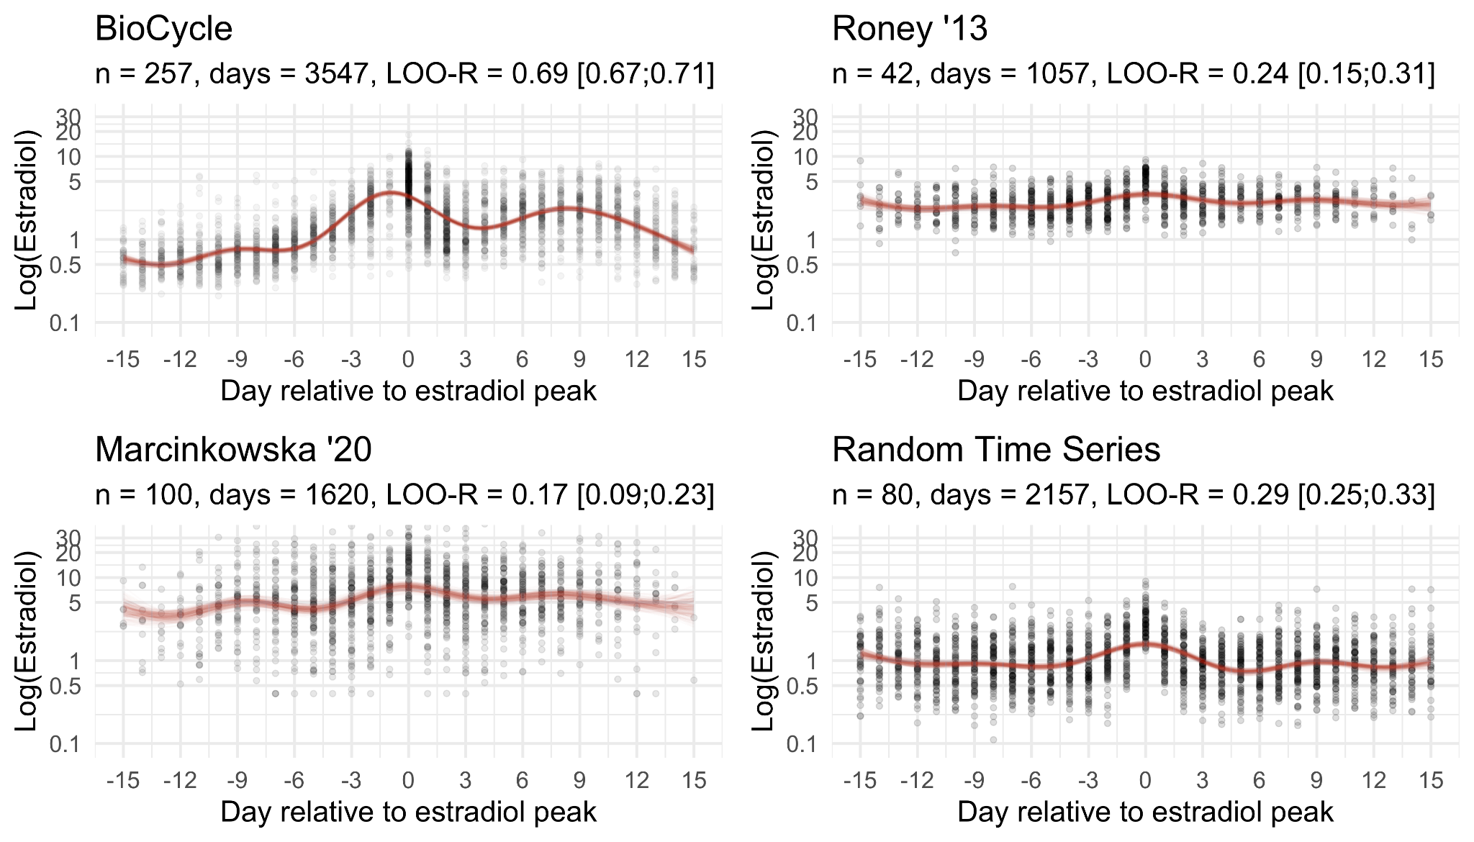
Supplementary Figure 4. Log (free) estradiol according to the day of the estradiol peak. The figure shows the three datasets with a sufficient number of measurement time points per individual to find the midcycle peak per cycle, as well as one simulated dataset that was set up to contain ~30 days per individual as stationary, autocorrelated time series (see OSF for detailed code).

Supplementary Note 3: Calculating the expected correlation between serum and saliva
We assumed linear associations and that there is no direct causal relationship between cycle phase (CP) and saliva steroid levels, so that the association is fully accounted for by serum steroid levels (i.e. the causal graph resembles one of, CP -> Serum -> Saliva, or Saliva <- Serum -> CP). If these assumptions hold, i.e. there is no path from cycle phase to saliva steroid levels except via serum steroid levels, we can derive the correlation between serum and saliva levels from their respective correlations with cycle phase (in this case, our cycle-phase-imputed expectations for each steroid) by standard path tracing rules (Wright, 1934). Tracing the path from cycle phase to serum steroid levels to salivary steroid levels, we can obtain the expected correlation between salivary levels and cycle phase by multiplying the cycle phase serum correlation with the saliva serum correlation.
Eq. 0: ${r_{Cycle phase, Saliva}=}_{}r_{Serum, Saliva}⋅ r_{Cycle phase, Serum}$
Eq. 1: $r_{Serum, Saliva}=\frac{{r_{Imputation, Saliva}}_{}}{r_{Imputation, Serum}}$
Solving the resulting equation (Eq. 0) for $r_{Serum, Saliva}$ gives us Eq. 1, a way to estimate the expected correlation between serum and salivary steroid levels. We impute the average serum values based on the BioCycle cubic spline models from cycle phase and use these as our measure of cycle phase (i.e., a definition of cycle phase based on expected average steroid levels). We use within-subject differences in serum and saliva hormones as our measure of serum/salivary steroid levels. Our estimate of $r_{Serum, Saliva}$ will be biased downward if the cycle phase measure is measured with more error in the saliva studies than in the serum study, and vice versa. Concretely, if there were more anovulatory cycles in a saliva study than in the serum study, a counting-based cycle phase measure, which ignores anovulation, would lead to lower estimated validities (see e.g. Supplementary Note 4). This form of bias is likely less important for urinary luteinising hormone based measures. However, these LH tests also differ in their sensitivity across studies (see Supplementary Note 7). T he BioCycle fertility monitor was the only one to use a digital readout of both urinary estrogen metabolites and luteinising hormone, but we used only the LH surge day from the BioCycle fertility monitor.
Our estimate would also be biased downward, if variation in cycle phase was more restricted in a saliva study (as, e.g., in Marcinkowska, 2020), but we adjusted for range restriction to bring the correlations to a common denominator and avoid this bias.
We show 95% confidence intervals for these estimated correlations in Figure 4. These only include uncertainty in the numerator (i.e., we divided the lower and upper 95% interval bound of $r_{Imputation, Saliva}$ by the mean estimate for $r_{Imputation, Serum}$). Uncertainty in the denominator (explained variance in the BioCycle study) was quite low (all standard errors at most 0.01, but would of course additionally increase the uncertainty of the expected correlations.To give two examples: we can estimate the correlation between serum ELISA of progesterone and salivary tandem mass spectrometry of progesterone as done in Jünger et al. (2018) as follows: Measured salivary log progesterone values correlate .62 with values imputed from the cycle day relative to the LH surge. If we centre log hormones within-subject and correct for range restriction, the correlation increases to .72. If we divide .72 by the corresponding correlation for the serum ELISA in BioCycle, which is .89, we obtain .81, our estimate of how strongly steroid ELISA log progesterone values would correlate with salivary LC-MS/MS log progesterone values taken on the same day. Going through the same procedure for salivary estradiol in Jünger et al. (2018), the correlation with LH-imputed values is .07 and .03 after centering within-subjects and adjusting for range restriction. Dividing .03 by .79, we arrive at an estimate of .04 for the correlation between the salivary immunoassay for estradiol and the serum ELISA for estradiol.

Supplementary Note 4: Anovulation rates and imputation accuracy by age
We used algorithms 4 and 7 from Lynch et al. (2014) to determine likely anovulatory cycles in the BioCycle data. We then estimated a model using several demographic factors (age, ethnicity, partnered, ever used birth control, BMI, high school education, parity, smoker) to predict anovulation. Only the 95% CI for age excluded zero. Using algorithm 4 based on serum progesterone and LH, we found that at age 18, 26.8% of cycles were predicted to be anovulatory. This rate reduced nonlinearly to 8.9% at age 22, 2.0% at age 30, and 1.1% at age 44 according to a Bayesian Poisson regression with only a cubic spline over age as the predictor to estimate the rate of anovulation per cycle continuously. Algorithm 7, the urinary fertility monitor classified far more cycles as anovulatory (see Supplementary Figure 5; Lynch et al., 2014). Based on the relationship with age, some of the included studies (especially Roney '13, OCMATE, Grebe '16) may have included substantially more anovulatory cycles than the BioCycle data. The accuracy of imputed hormones could be deflated in younger samples as a result. To quantify this deflation, we restricted the BioCycle data to the n=101 individuals aged 18-22. LOO-R using days relative to the urinary LH surge as the predictor of log free estradiol was 0.70 [0.66;0.73] and using backward-counted days, it was 0.66 [0.63;0.69], compared to 0.72 and 0.68 for the whole sample. For progesterone, the respective values were LOO-R 0.81 [0.77;0.84] and 0.75 [0.71;0.78], compared to 0.87 and 0.83 (see Supplementary Figure 6). In addition, the Marcinkowska '20 sample was older than the BioCycle sample on average, yet showed comparable results to other datasets. In summary, age and anovulation cannot fully explain the discrepancy in variance explained by cycle phase across saliva and serum studies.

Supplementary Figure 5
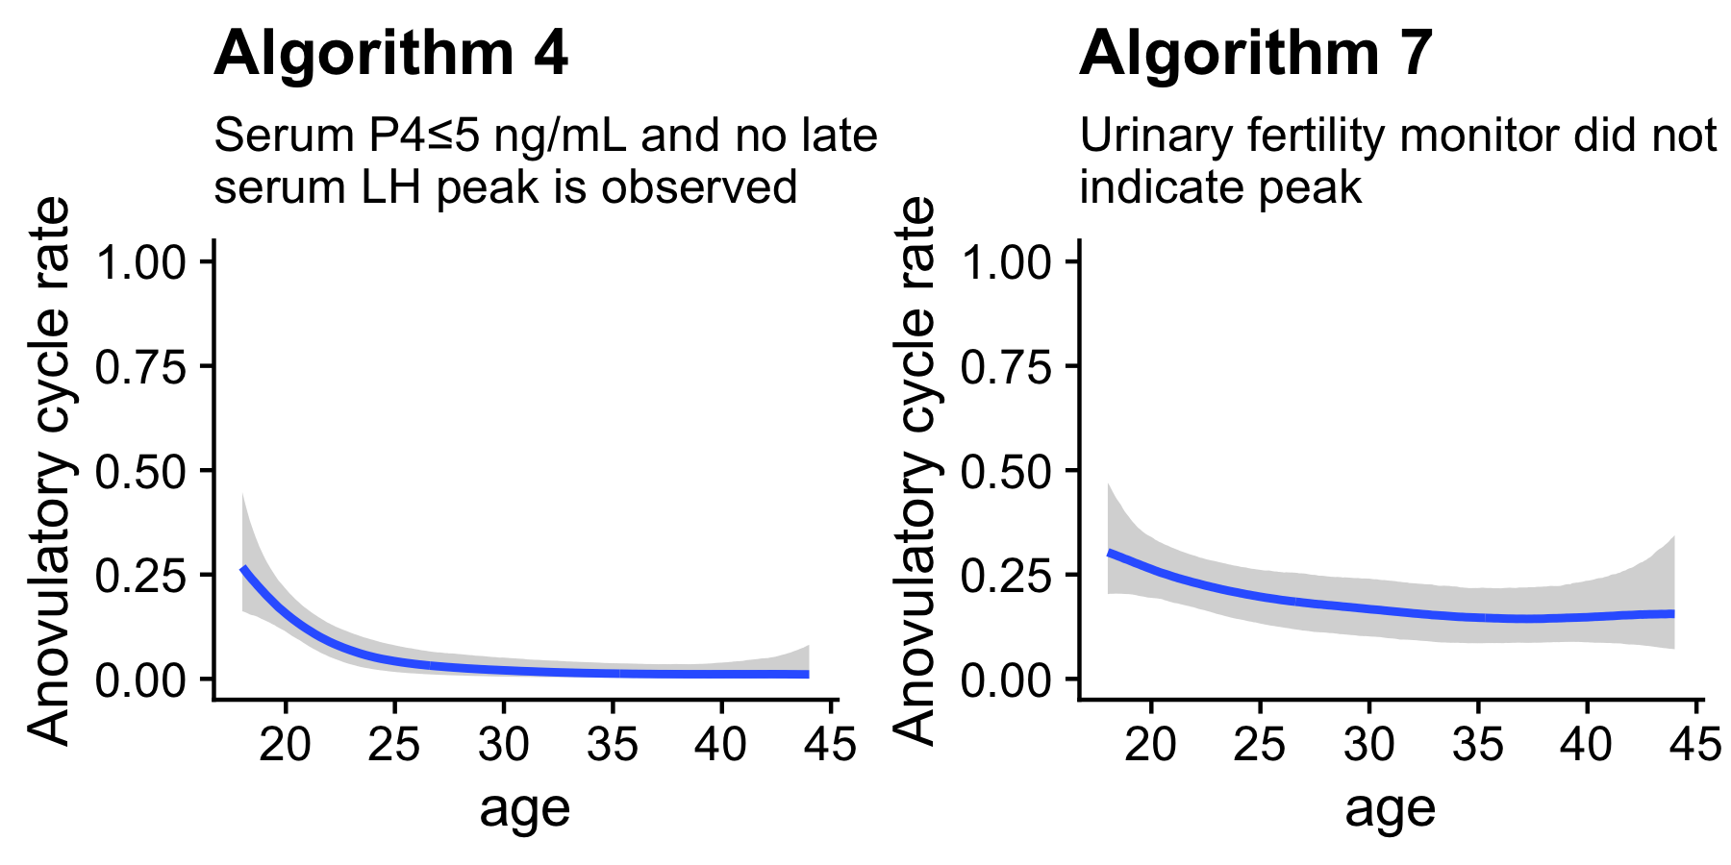
Supplementary Figure 5. Model-estimated rate of cycles classified as anovulatory by age in the BioCycle data, according to one serum-based and one urine-based algorithm.

Supplementary Figure 6
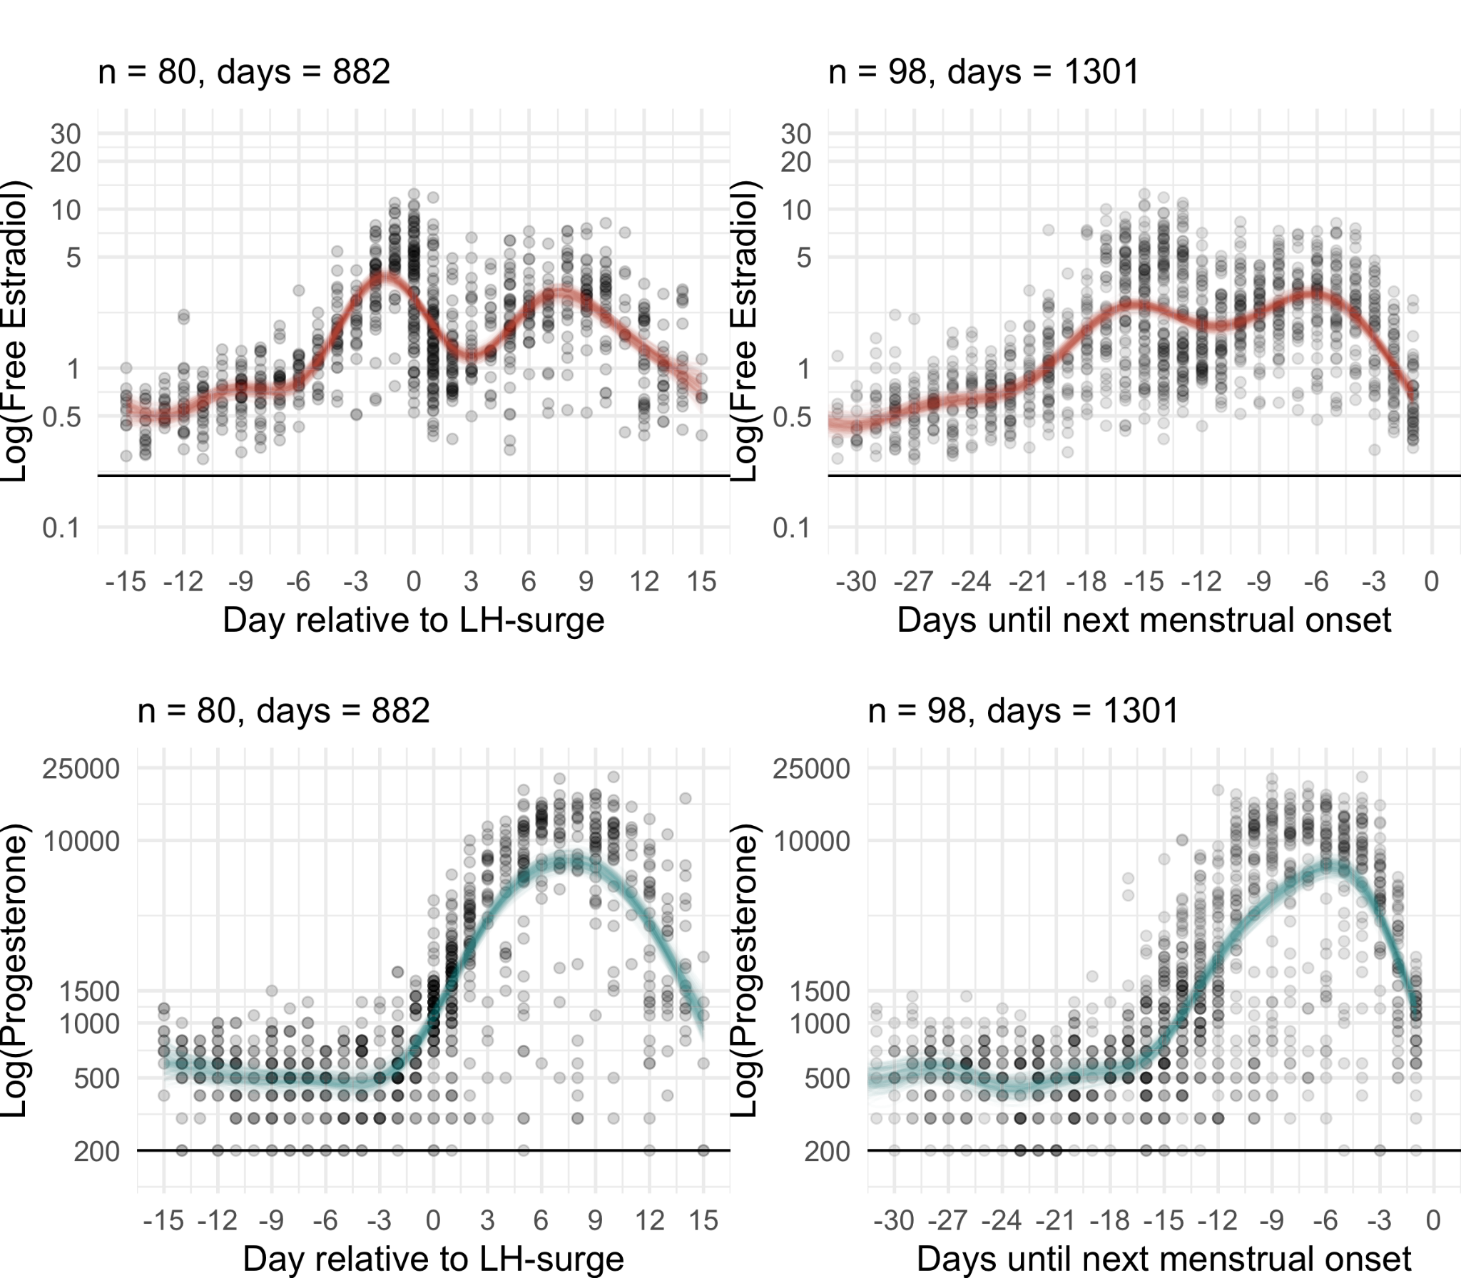
Supplementary Figure 6. Log free estradiol and log progesterone according to the urinary LH surge and observed next menstrual onset in all individuals 18-22 in the BioCycle data.

Supplementary Note 5: Serum steroids according to the serum luteinizing hormone surge
The BioCycle study measured LH both using a serum immunoassay and a ClearBlue home fertility monitor based on urine test strips. For imputation and for comparison with the salivary steroid studies, the urinary measure was more interesting to us. However, to facilitate comparisons with the literature (Stricker et al., 2006) and to understand how well steroids can be imputed from LH surges if they are measured with less error in studies collecting serum, we also computed the relationship between steroids and the cycle day relative to the serum LH surge (the first day of the cycle where LH > 20 ng/ml). For log estradiol, the LOO-R was 0.76 (95% CI [0.74;0.78]). For log progesterone, the LOO-R was 0.91 [0.90;0.92], see also Supplementary Figure 4.
We also computed correlations between average hormones and the 5% and 95% percentiles reported in Stricker et al. (2006) according to the LH peak, to see whether our imputations were generalizable. The means computed by Stricker et al. (2006) correlated .99 with the means computed by us in the BioCycle data for both estradiol and progesterone. The 5% and 95% percentiles were correlated between .90 and .97 across studies. In a plot, absolute levels also were highly similar. Thus, both means and estimates of variability across individuals were highly similar across two high-quality studies based on serum.

Supplementary Figure 7

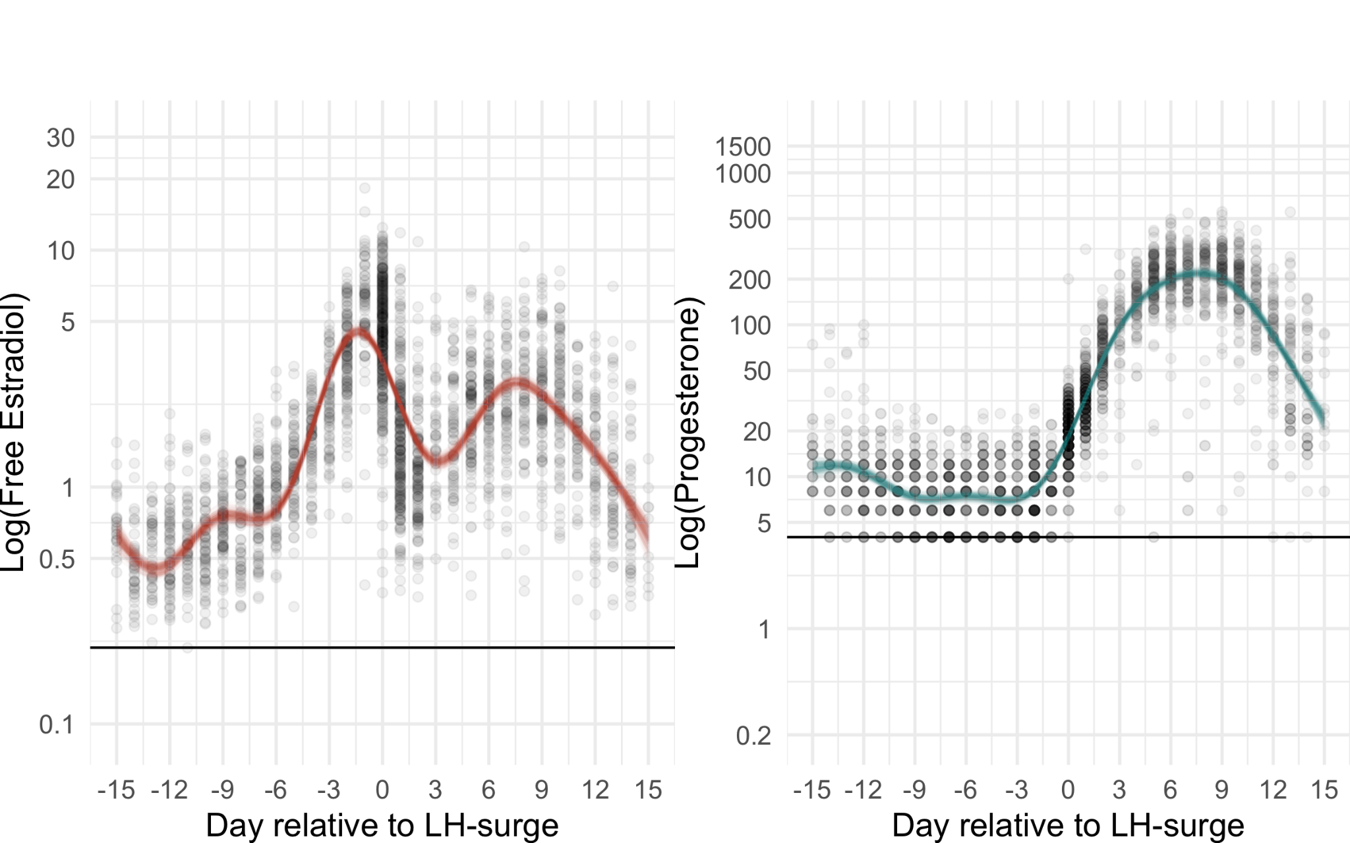
Supplementary Figure 7. Log free estradiol and log 2% progesterone according to the serum LH surge in the BioCycle data.

Supplementary Note 6: Urinary validity data.

Urinary immunoassays of estrogen and progesterone metabolites are an infrequently used non-invasive alternative to salivary immunoassays (see Supplementary Note 1). Roos et al. (2015) report correlations of r=0.54 and r=0.82 between estradiol and progesterone in serum and their respective urinary metabolites one day later in a sample of 40 individuals who participated for an entire cycle (see also Denari et al., 1981). These validities, while suggesting an improvement over salivary immunoassays for estradiol, are still lower than those for our values imputed from cycle phase (backward-counting and LH) in the BioCycle data. But unlike imputation, urinary assays additionally permit examination of between-cycle and between-individual variation. Yet, if within-cycle effects are of interest and budgets constrained, researchers could achieve higher statistical power through imputation from inexpensive LH tests or backward counting methods.

We cite the Roos et al. (2015) coefficients for the urine-serum correlation. They are interpretable as coefficients of validity, as they reflect correlations between individual matched samples. Other work (e.g. Gordon et al., 2021) has on occasion cited O’Connor et al. (2003) to show validity of urinary immunoassays. O'Connor et al. (2003) report r=.93 for estradiol and r=.97 for progesterone at a one day lag. However, O'Connor et al. (2003) aggregated values by cycle day before computing correlations. Therefore, the correlations are extremely inflated if taken as indicators of the validity of individual measurements. For comparison, we merged the aggregated serum values by cycle day reported in Roos et al. (2015) with the urine values reported in Johnson et al. (2015) for the same dataset. Correlations at a one day lag were r=0.90 for estradiol and r=0.98 for progesterone and their respective metabolites.

Supplementary Note 7: Methodological details for each study.

 | BioCycle | Roney 2013 | OCMATE | Marcinkowska 2020 | Stern 2021 | Jünger 2018 | Blake 2017 | Grebe 2016
Exclusions gender | none | none | none | none | not applicable | not applicable | none | not applicable
Exclusions anovulatory/irregular | 21-35 days last 6 months  various medical/lifestyle indicators, esp. Chlamydia IgG | cycle length < 40 days | none | consecutive cycles vary less than 5 days | 25-35 days,  vary less than 5d  various medical indicators | 25-35 days | anov. LH  various medical conditions | none
LH test manufacturer | Clearblue (LH+E3g) | none | none | NA | MedNet GmbH | purbay® | Blue Cross Bio-Medical Co. LTD | none
LH test sensitivity | 30mIU/ml | NA | NA | 20mIU/ml | 10mIU/ml | 10mIU/ml | 25mlU/ml | NA
LH test days | 6th FC  up to 20 | NA | NA | 10th-20th FC  up to 10 | M-S+2  up to 10 | -4 to O  5 days | until pos.  up to 11 days | NA
Avoid | E 12h | ED 30m  rinse mouth | AC 12h  EDSGT 1h | EDS 30m | AR 24h  C 3h  SpM same day  EDSGT 1h | AR 24h  C 3h  SpM same day  EDSGT 1h | R 30d  AS 12h  EDC 1h | ED 1h
Sampling schedule | on eight days spread through the cycle | each day, assayed on nine days centred on 15 days prior to next menstrual onset, alternating days outside this window | sampling was random with respect to cycle day | each day, preferentially assayed on the 15 days surrounding the est. day of ovulation for estradiol, in the luteal phase for progesterone | two samples in mid-to-late follicular, one midluteal, one premenstrual sample | one sample in fertile phase, one in midluteal phase | one fertile sample, one non-fertile sample (early follicular or late luteal) | sampling was random with respect to cycle day
Sampling time | routinely 7:00-8:30 | morning  ideally after waking | attempted to keep constant per individual  pre-/post-task randomised | morning  pre-tasks | 12:00-16:00  pre-stimuli | 11:30-16:00  pre-stimuli | 12:00-18:00 | 12:00-18:00 (Sample 1), Waking Time (Sample 2)
Specimen collection | phlebotomy | passive drool | passive drool | ? | passive drool | passive drool | passive drool | passive drool
Freezing | -80°C, 1 FT | home freezer, participants transported to lab, then -80°C | −32° C, 1 FT | home freezer, portable freezers | -80°C, 1 FT (transport on dry ice) | -80°C, 1 FT for P4, 2 FT for E2, (transport on dry ice) | −20° C (transport on dry ice) | −20° C, 1 FT
Estradiol
Assay | Siemens  IMMULITE | Salimetrics  #1-3702 | Salimetrics  #1-3702 | DRG  SLV4188 | IBL  30121045 | IBL  RE62141 / RE62149 | IBL | Salimetrics  #1-3702
Limit of quantitation (pg/ml) | NR | 1.00 | 1.00 | 1.00 | 2.10 | 0.90 | NR | 1.00
Limit of detection (pg/ml) | 0.21 | 0.10 | 0.10 | 0.40 | 2.10 | 0.30 | 2.10 | 0.10
Intraassay CV | NR | 7.13% | 4.52% | 7.5% | 8.80% | 9.70% | <12% | 6.58%
Interassay CV | <10% | 7.45% | 8.15% | 10.1% | 11.80% | 11.30% | <12% | 2.68%
Progesterone
Assay | Siemens  IMMULITE | Siemens Health Diagnostics | Salimetrics  1-1502 | DRG  SLV-2931 | Ab Sciex  LC-MS/MS | Ab Sciex  LC-MS/MS | IBL | Salimetrics  1-1502
Limit of quantitation  (pg/ml) | NR | 10.00 | NR | 10.00 | 5.00 | 5.00 | NR | 10.00
Limit of detection (pg/ml) | 200.00 | 5.00 | 9.14 | 2.50 | NR | NR | 8.90 | 5.00
Intraassay CV | NR | 6.20% | 4.57% | 4.9% | 10.80% | 10.80% | <12% | 14.52%
Interassay CV | <10% | 7.55% | 7.36% | 14.1% | 9.70% | 9.70% | <12% | 4.83%

Note: Exclusions gender: none = gender was not collected and hence not screened, not applicable = only cisgender women applied to enrol.
FT=Freeze-thaw cycles

M-S+2 = end of menstruation until two days after tests were negative.
-4 to O: at the estimated day of ovulation and the four days prior to that

A=alcohol, E=eating, D=drinking (except plain water), C=caffeine, S=smoking, G=chewing gum, T=brushing teeth, R = recreational drug use, Sp = sport, M = medication

NR = not reported

Supplementary Note 8: All model sample sizes.

Dataset | Hormone | Forward counting | Backward counting | LH surge
BioCycle | Estradiol | 3676/481/257 | 3425/448/246 | 2550/340/214
 | Progesterone | 3676/481/257 | 3425/448/246 | 2550/340/214
Roney '13 | Estradiol | 1091/88/42 | 1039/71/41 | NA
 | Progesterone | 1121/90/42 | 1065/71/41 | NA
OCMATE | Estradiol | 1552/618/349 | 773/312/255 | NA
 | Progesterone | 1552/618/349 | 773/312/255 | NA
Marcinkowska '20 | Estradiol | 1647/100/100 | 1647/100/100 | 1221/75/75
 | Progesterone | 1550/99/99 | 1550/99/99 | 1133/74/74
Stern '21 | Estradiol | 913/406/243 | 895/388/242 | 647/259/196
 | Progesterone | 778/377/238 | 763/362/238 | 545/241/188
Jünger '18 | Estradiol | 374/243/125 | 543/356/157 | 426/256/145
 | Progesterone | 368/240/124 | 532/350/156 | 412/247/143
Blake '17 | Estradiol | 114/103/58 | 110/99/58 | 89/84/58
 | Progesterone | 114/103/58 | 110/99/58 | 89/84/58
Grebe '16 | Estradiol | 58/31/31 | NA | NA
 | Progesterone | 57/31/31 | NA | NA

Note. Sample sizes at the three levels of each multilevel model are given as "number of days/number of cycles/number of individuals".

Supplementary Note 9: Sensitivity analyses
A reviewer raised the possibility that a) explained variance in the BioCycle models might exaggerate out-of-sample validity to such an extent that our imputation approach should not be recommended and b) that our statistical correction for restriction of range might fail to adequately recover the true correlations for studies such as Jünger et al. (2018), which scheduled sampling days so that menses and the days immediately following ovulation were rarely observed (and so days with particularly low expected estradiol values rarely observed).
Rather than go into depth on the underlying statistical reasoning, we conducted two simple sanity checks using a different sample.
Stricker et al. (2006) report mean values for estradiol and progesterone by cycle day relative to the serum LH surge. Because the day of the serum LH surge is rarely available, their values have limited utility for the imputation approach we suggest. However, because Stricker et al. (2006) is an independent sample, these values cannot suffer from overfitting to the BioCycle data. We merged the mean values from Stricker et al. (2006) on the cycle day relative to the urinary LH surge in the BioCycle data to impute expected mean estradiol and progesterone. Log estradiol was correlated with log imputed estradiol at .73 [.71;.75] and log progesterone was correlated with log imputed progesterone at .86 [.85;.87]. The value for estradiol is close to our LOO-R estimate of .72 and the value for progesterone is close to our LOO-R estimate of .87. The close replication is even more notable because discrepancies could have arisen a) because of a mismatch between the urinary LH surge and the serum LH surge, b) because the Stricker et al. (2006) data included only N=20 individuals c) because Stricker et al. (2006) do not report geometric means, so the reported means are sensitive to outliers under a lognormal distribution. Hence, the small discrepancies support the LOO-R validities we report for our imputations and support cautious generalisation to other samples.
In a next step, we filtered out all days from the BioCycle data that were more than three days prior to the LH surge, as well as days 1-4 after the LH surge. We filtered these days to approximate the sampling schedule of Jünger et al. (2018), the study with the most restricted schedule with respect to imputed estradiol variance. After restriction, variance of the imputed estradiol scores was 35% of the population variance (compared to 43% in Jünger et al., 2018). After creating this restricted dataset, we again computed the aforementioned correlations with the Stricker et al. (2006) values. They were .55 [.51;.59] and .85 [.83;.86] for estradiol and progesterone respectively. So, even after restricting the variance in cycle phase more severely than in Jünger et al. (2018) so as to entirely cut out the post-ovulatory estradiol dip, we still observed sizable correlations between imputation and measured hormone values. After applying the correction for range restriction, the correlation was .75 [.71;.78] for estradiol and .87 [.86;.88] for progesterone. That is, the correction for range restriction successfully recovered the correlation before artificial range restriction ± 0.02.

Supplementary References
Denari, J.H., Farinati, Z., Casas, P.R., Oliva, A., 1981. Determination of ovarian function using first morning urine steroid assays. Obstet. Gynecol. 58, 5–9.
Gordon, J.L., Halleran, M., Beshai, S., Eisenlohr-Moul, T.A., Frederick, J., Campbell, T.S., 2021. Endocrine and psychosocial moderators of mindfulness-based stress reduction for the prevention of perimenopausal depressive symptoms: A randomized controlled trial. Psychoneuroendocrinology 130, 105277. https://doi.org/10.1016/j.psyneuen.2021.105277
Johnson, S., Weddell, S., Godbert, S., Freundl, G., Roos, J., Gnoth, C., 2015. Development of the first urinary reproductive hormone ranges referenced to independently determined ovulation day. Clin. Chem. Lab. Med. 53, 1099–1108. https://doi.org/10.1515/cclm-2014-1087
O’Connor, K.A., Brindle, E., Holman, D.J., Klein, N.A., Soules, M.R., Campbell, K.L., Kohen, F., Munro, C.J., Shofer, J.B., Lasley, B.L., Wood, J.W., 2003. Urinary estrone conjugate and pregnanediol 3-glucuronide enzyme immunoassays for population research. Clin. Chem. 49, 1139–1148. https://doi.org/10.1373/49.7.1139
Roos, J., Johnson, S., Weddell, S., Godehardt, E., Schiffner, J., Freundl, G., Gnoth, C., 2015. Monitoring the menstrual cycle: Comparison of urinary and serum reproductive hormones referenced to true ovulation. Eur. J. Contracept. Reprod. Health Care 20, 438–450. https://doi.org/10.3109/13625187.2015.1048331
Stricker, R., Eberhart, R., Chevailler, M.-C., Quinn, F.A., Bischof, P., Stricker, R., 2006. Establishment of detailed reference values for luteinizing hormone, follicle stimulating hormone, estradiol, and progesterone during different phases of the menstrual cycle on the Abbott ARCHITECT analyzer. Clin. Chem. Lab. Med. 44, 883–887. https://doi.org/10.1515/CCLM.2006.160
Wright, S., 1934. The Method of Path Coefficients. Annals of Mathematical Statistics 5, 161–215. https://doi.org/10.1214/aoms/1177732676

